Christmas at Castle Bistro
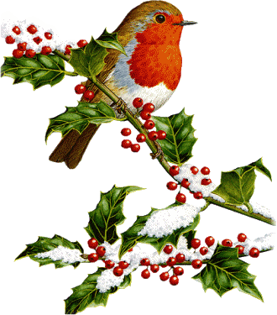
Two Course 19.95 Three Course 23.95

STARTERS

GAMBERETTI
Battered king prawns, tartare sauce, rocket & balsamic

BEETROOT & TOMATO SOUP
Finished with cream, chives & warm ciabatta

MULLED WINE CONFIT DUCK SALAD
With figs, rocket, orange & pine nuts

CRANBERRY WENSLEYDALE MUSHROOMS
In a creamy garlic & chive sauce, on a toasted ciabatta

MAINS

BISTRO FESTIVE TURKEY DINNER
Sliced turkey breast, sausage, bacon, sage & onion buttermilk fried stuffing ball, creamy mashed potato, pigs in blanket, rocket, gravy served with seasonal vegetables & Parmentier potatoes

POLLO MILANO
Chicken breast in a creamy white wine garlic sauce, with chorizo, served with sautéed potatoes & rocket

CONFIT DUCK LEG
Creamed mashed potato, gravy, complemented with a cherry red sauce & served with seasonal vegetables

PAN FRIED SEA BASS
With Mediterranean lentils, cherry tomatoes, tomato & basil pesto sauce, served with seasonal vegetables & Parmentier potatoes

FALAFEL SORENTO
Pine nut chickpea falafel topped with brie cranberry sauce, pesto in a tomato basil sauce on mashed potato, served with seasonal vegetables & Parmentier potatoes

DESSERTS

CHRISTMAS PUDDING
With brandy sauce

DARK CHOCOLATE & SALTED CARAMEL TART A rich chocolate tart with a layer of salted caramel, served with Chantilly cream

BAILEYS & WHITE CHOCOLATE CHEESECAKE Topped with white chocolate shavings, served with vanilla ice cream & a berry compote

BANOFFEE MERINGUE ROULADE
With a berry compote

CITRON TART
Tangy tart made with fresh lemon, served with Chantilly cream
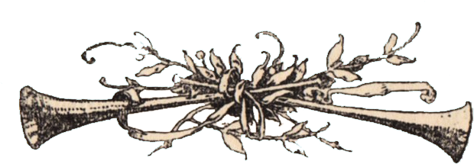

IF YOU HAVE A FOOD ALLERGY, PLEASE LET US KNOW BEFORE ORDERING!

www.castlebistro.co.uk 01691 239133

